PRN NO:- 220940520044

NAME:- Kaustubh Pandit Kasote

Code:

package Exam;

import org.openqa.selenium.By;

import org.openqa.selenium.chrome.ChromeDriver;

public class SDM {

ChromeDriver driver=new ChromeDriver();

public void open()

{

System.*setProperty*("webdriver.chrome.driver","D:\\DAC\\SDM\\Testing\\chromedriver_win32\\chromedriver.exe");

//To get Url

driver.get("http://www.google.co.in/");

driver.manage().window().maximize();

String s = driver.getCurrentUrl();

System.***out***.println("Current url is "+s);

//For googleApps open and select Maps

driver.findElement(By.*partialLinkText*("Maps")).click();

driver.findElement(By.*className*("gb_Ze")).click(); //googlemap

driver.findElement(By.*cssSelector*("Rq5Gcb")).click(); //click

//for CDAC search

driver.findElement(By.*xpath*("/html/body/div[1]/div[3]/form/div[1]/div[1]/div[1]/div/div[2]/input")).sendKeys("CDAC");

driver.findElement(By.*cssSelector*("Search")).click();

}

public void SignIn()

{

driver.findElement(By.*partialLinkText*("Sign in")).click();

driver.findElement(By.*cssSelector*("ltr")).sendKeys("harshukasote123@gmail.com");

}

public static void main(String[] args) {

SDM o = new SDM();

o.open();

o.SignIn();

}

}

1) Open the url

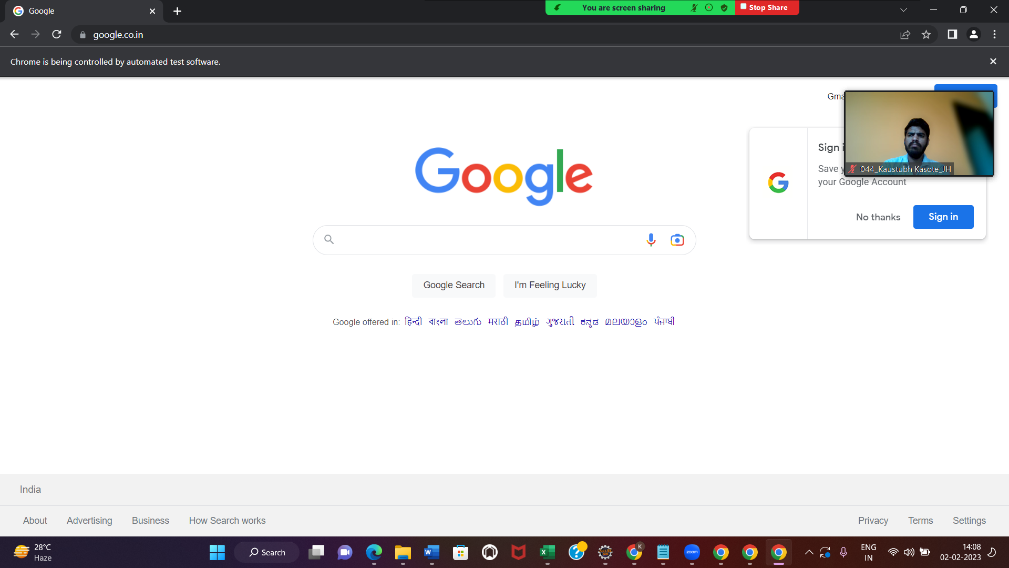

2) Go to SignIn

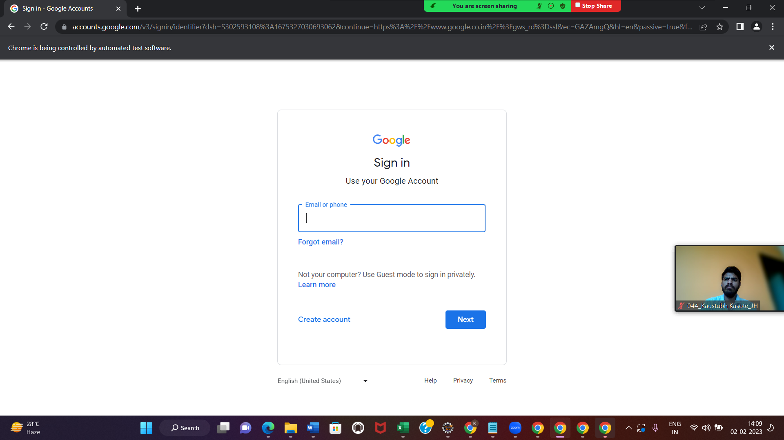

4)click on google apps 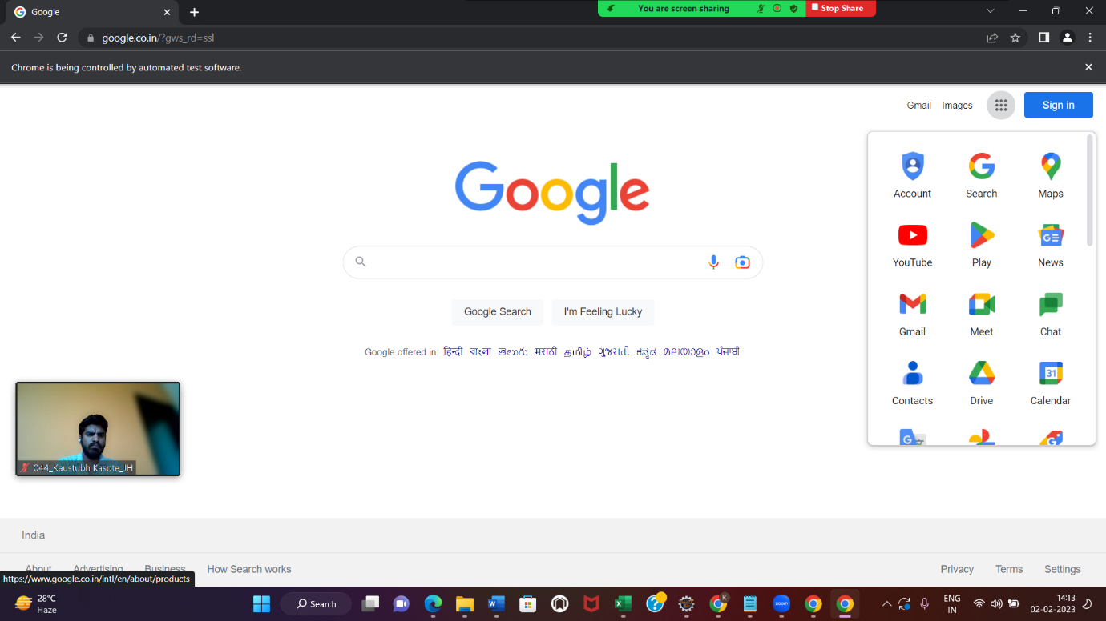

5)click on maps

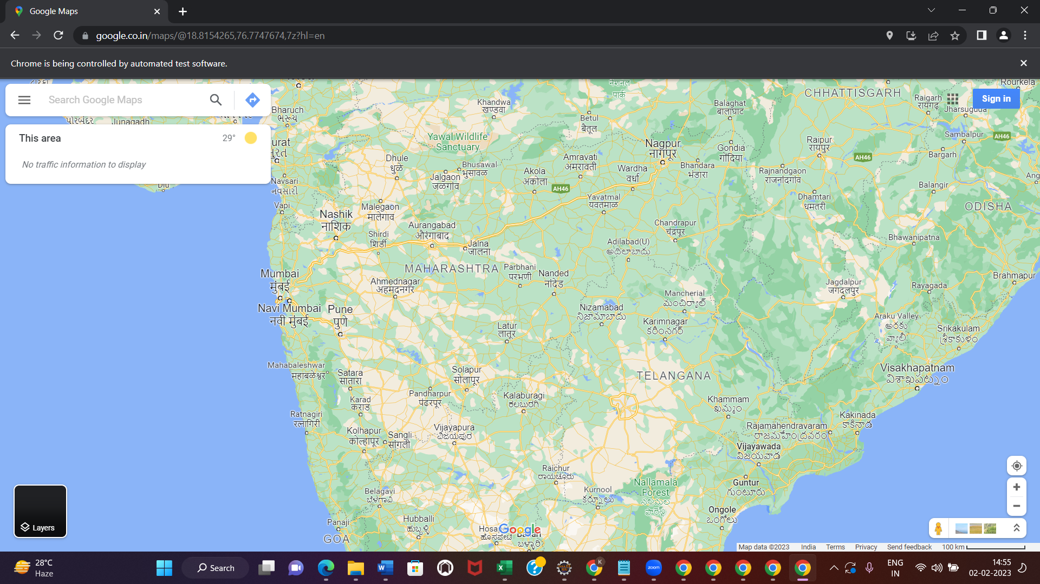

5)search for CDAC

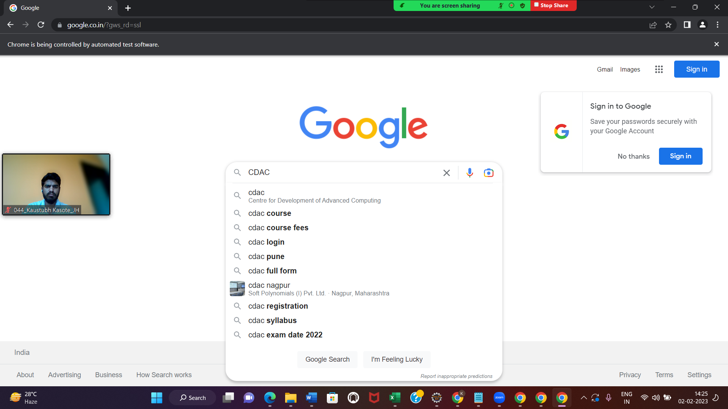

Section2:GIT

Git init

$ git branch -m Branch3

$ git add .

$ git status

$ git remote add origin <https://github.com/kaustubhkasote/ExamSample.git>

$ touch File1.txt

$ vi File.txt

$ git commit -m "Create java file with linked list code with 4 nodes code and call commit"

$ git push -u origin Branch3

============================For branch2:-

$ git branch -m main2

$ git add .

$ git status

$ git remote add origin <https://github.com/kaustubhkasote/ExamSample.git>

$ touch File1.txt

$ vi File.txt

$ git commit -m "Update java file with insertion_at_end() code with switch case and call commit."

$ git push -u origin main2

For branch3:-

============================For branch2:-

$ git branch -m main2

$ git add .

$ git status

$ git remote add origin <https://github.com/kaustubhkasote/ExamSample.git>

$ touch File5.txt

$ vi File.txt

$ git commit -m "third branch"

$ git push -u origin main2